database final project university database 

 Team
Shehab Magdy Elsayed 22011558
Ahmed Nayer Mahmoud 20221443165
Mahmoud Mohamed Ahmed 22010240
Mosaab Galal Eldeen 22011627

Business Requirments
The business requirements for a university database model should be able to fulfill:
- student management: database admin should be able to add and manage
enrollment information about students, including their personal details (name, id, email, password, phone-number ,etc.) enrollment status.
- Faculty and major management: database admin should be able to manage the courses offered by the university, including course details, credit-hours, Teachers ,course fees and any other information necessary for course administration.
- staff and employee management: database admin should support the management of professors ,teachers and unacademic employees of the university allowing the user to manage their salary ,position and department and any other information to that topic.
- Enrollment and Registration: database admin should be able to do the enrollment and registration process for students, allowing them to enroll faculties and select majors, check availability, and any restrictions on enrollment , admin also responsible for the registration of new employees (staff and unacademic-employees) identifying their salary and department , position and their hire-date and any related information.

Business Rule details:
A university database where exist faculty including info about the faculty like name, id, years of study, address this faculty have many students that have attributes id, first name , last name, phone number, gender, email, password, birthdate, address and the faculty also will have a majors having attributes id , name for each faculty, this faculty offers many courses with attributes id, name, credit hours, fees, the university faculties have employees having attributes id, first name ,last name, nationality ,gender, salary, hire date, birthdate where this employees are distributed into two department Tutors i.e. staff and faculty employees e.g. security and un-academic employees these departments have their unique id and name ,

Entity-Relation diagram (erd)
CHEN MODEL

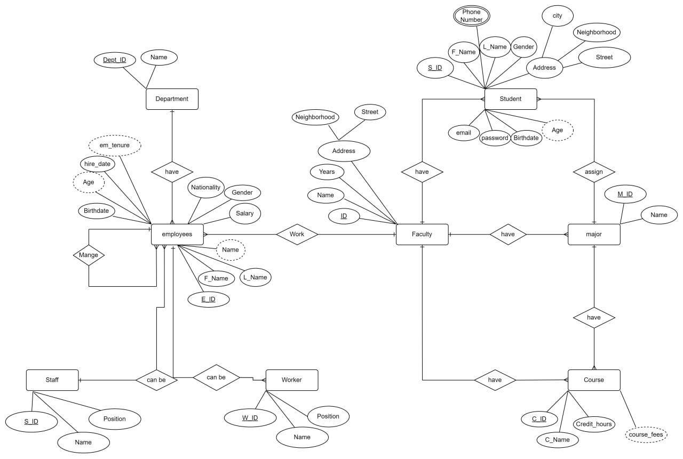

- Used Tool: draw.io

Crow’s foot MODEL

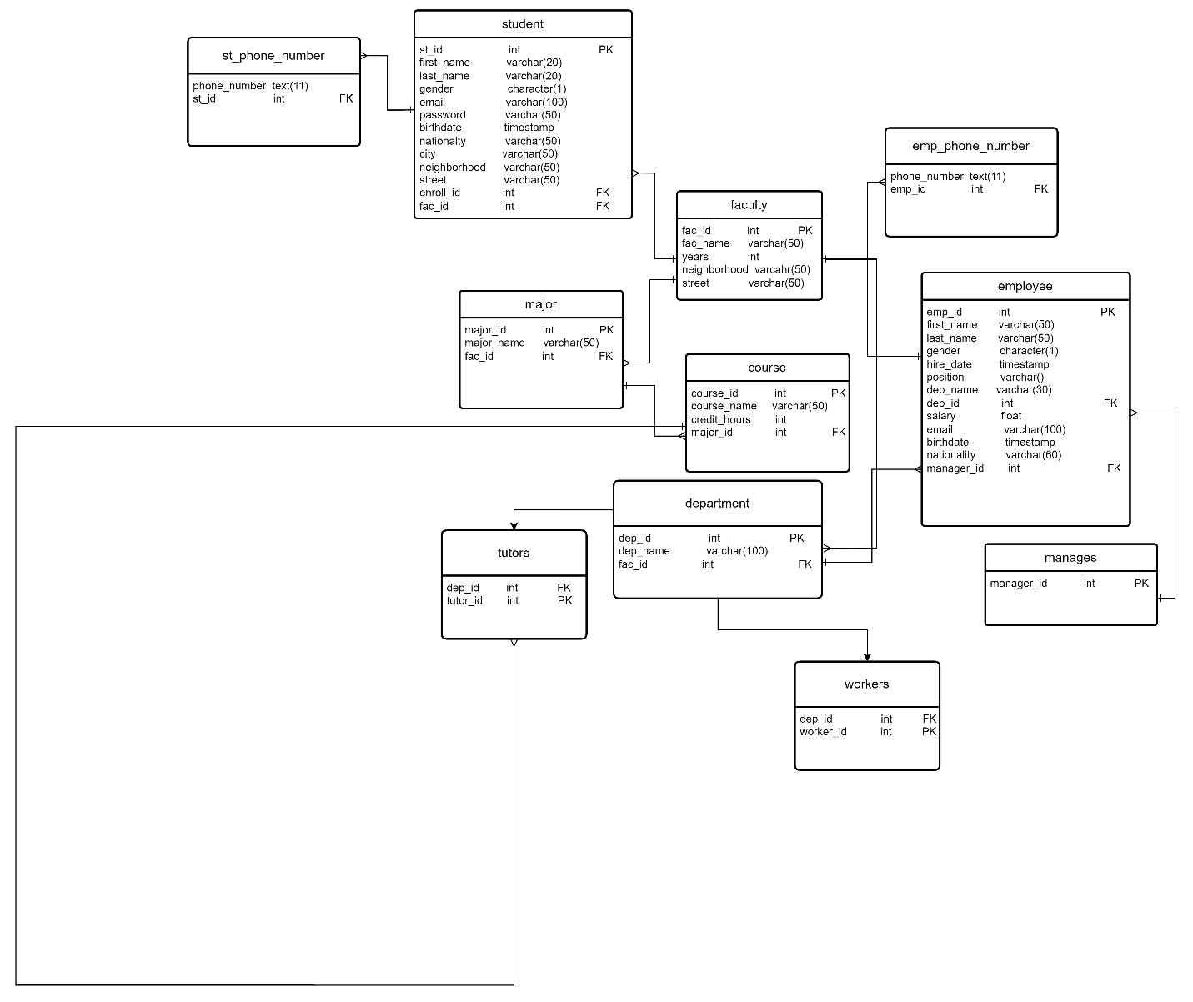

- Used Tool: draw.io

Logical schema

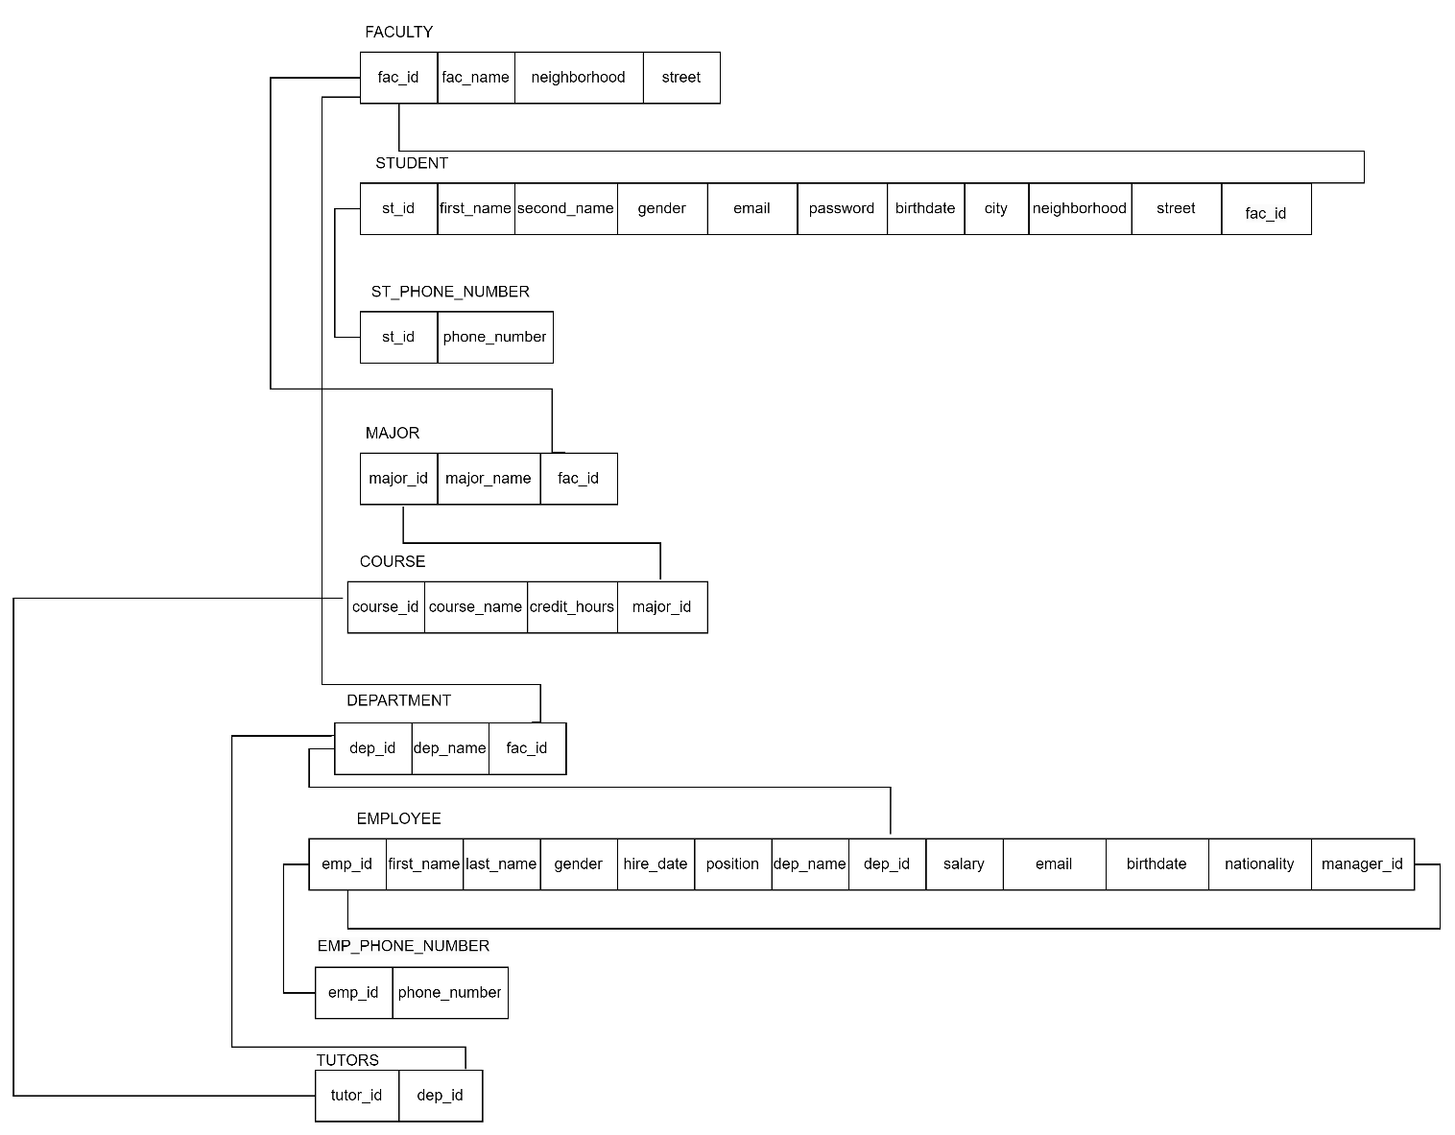

- Used Tool: draw.io

SQL IMPLEMENTaion

Full code on GitHub
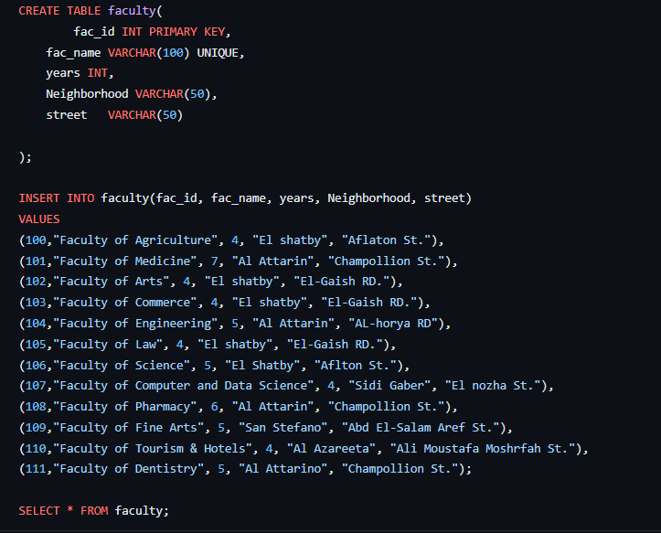

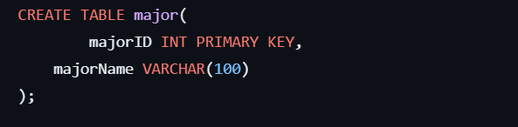

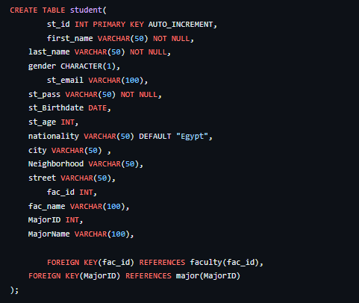
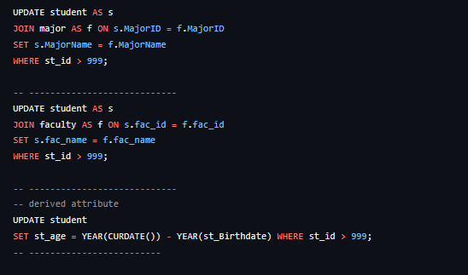

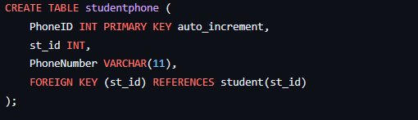

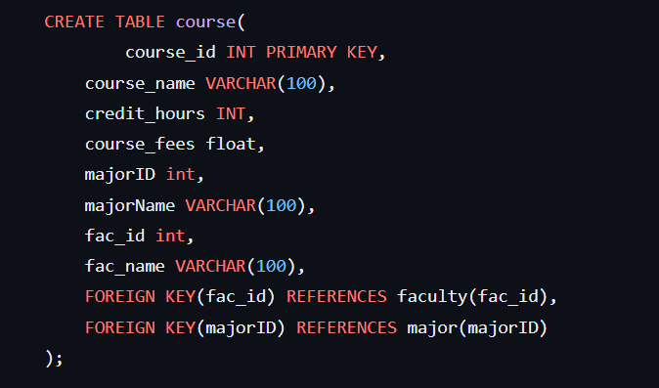

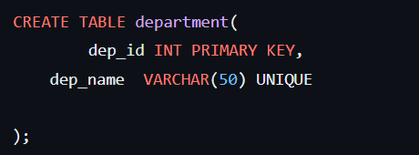

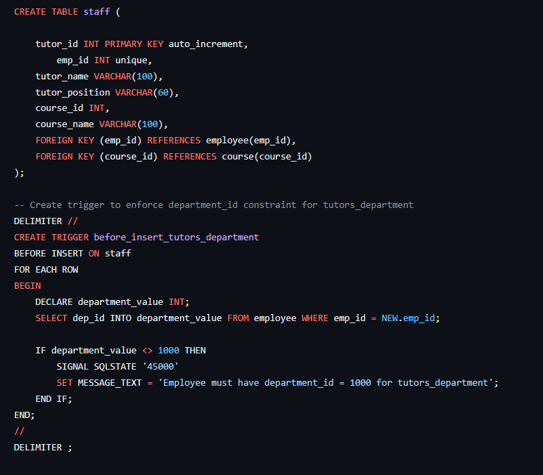

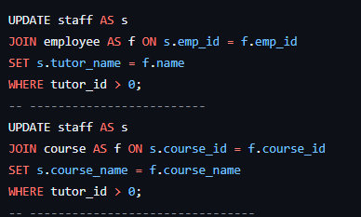

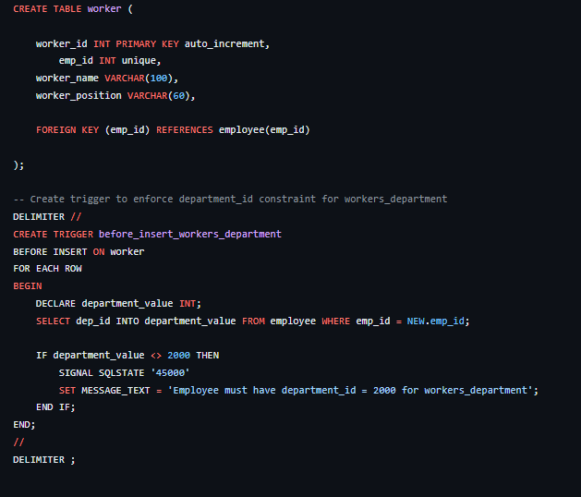

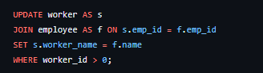

about this project

In this project we have created a relational database that follow series of stages of normalization till we reached the 3NF passing through the 1NF stage by creating table format and making sure no groups are repeated and the PK is identified continuing to the 2NF where 1NF is applied and no partial dependencies exist and to the 3NF the applies 1NF and 2NF and no transitive dependencies exist but that resulted in more and more tables and less processing speed but as an example when we created the “employee” table we have to check if an employee would have more than one phone number so we handled that by creating a new table for the “EmployeePhone” that will have multiple rows for the same exact employee if he/she had a more than one phone number.

